1. Soil C pool data was from Table 1 (page 5).

Soil C (OC g/cc)= Bulk density \* carbon content (%)

The paper does not report carbon density directly. We calculated carbon density from Table 1, which reported percent organic carbon and bulk density, but not carbon pool.

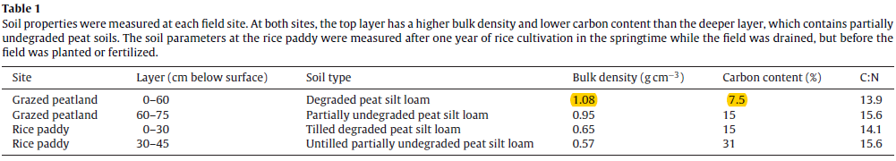

2. Soil C rate in this paper was from NEE data (Table 3), + values represent C emission while – values represent C sequestration.

According to the response from Blanca, we didn’t include these data due to the method (NEE) used in this study.

